#### Project Design Phase-II

#### Data Flow Diagram and User Stories

|  |  |
| --- | --- |
| **Date** | **19 November 2022** |
| **Team ID** | **PNT2022TMID05601** |
| **Project Name** | **IOT Based Smart Crop Protection System for Agriculture** |
| **Maximum Marks** | **4 Marks** |

**Data Flow Diagrams:**

A Data Flow Diagram (DFD) is a traditional visual representation of the information flows within a system. A neat and clear DFD can depict the right amount of the system requirement graphically. It shows how data enters and leaves the system, what changes the information, and where data is stored.

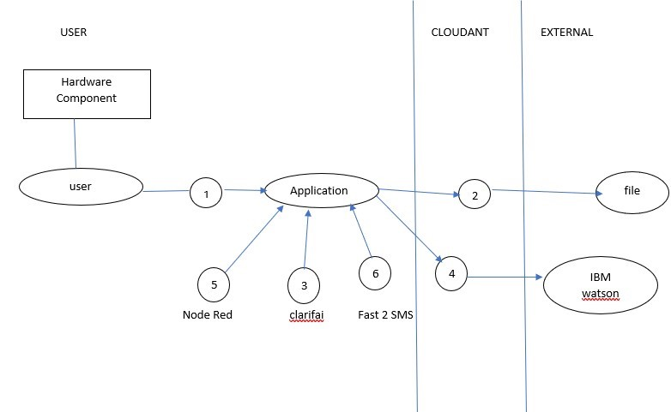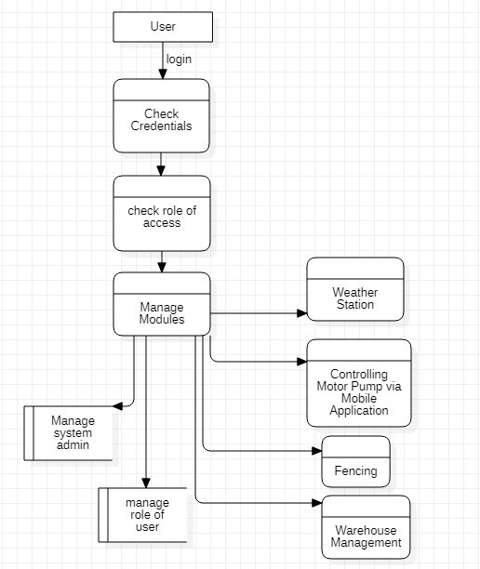

Example: DFD Level 0 (Industry Standard)

**User Stories**

|  |  |  |  |  |  |  |
| --- | --- | --- | --- | --- | --- | --- |
| **User Type** | **Functional**  **Requirement**  **(Epic)** | **User Story Number** | **User Story / Task** | **Acceptance criteria** | **Priority** | **Release** |
| Customer | Registration | USN-1 | As a user, I can register for the application by entering my email, password, and confirming my password. | I can access my account / dashboard. | High | Sprint-1 |
| Customer | Registration | USN-2 | As a user, I will receive confirmation message once I have registered for the application. | I can receive confirmation message & click confirm. | High | Sprint-1 |
| Administrator | Login page | USN-3 | As a user entering the username and password which is already existing. | Redirecting to user account. | Medium | Sprint-1 |
| Weather station | Forecasting the current weather | USN-4 | As a user, we can monitor the weather fundamentals like (humidity, wind speed, wind direction and rainfall). | Notified about weather conditions. | High | Sprint-1 |
| Controlling the Motor Pump | Controlling | USN-5 | It is used to control motors and field sprinklers. | Switching on and off the motor pump manually via mobile application | High | Sprint-2 |
| Fencing | Detecting the motion in certain range | USN-6 | Fencing system are helpful in providing security against unauthorized access of human and animal. | I can receive notification; prevention has been taken. | High | Sprint-3 |
| Warehouse management | Collecting database of crops | USN-7 | Here famer need to update about expire date of fertilizer and seeds. | Generate the popup message about expire date and stocks and offers | High | Sprint-4 |